

**Department of Computer Science**

This project has been satisfactorily demonstrated and is of suitable form.

This project report is acceptable in partial completion of the requirements for the Master of Science degree in Software Engineering.

|  |  |  |
| --- | --- | --- |
| **LYB-SYNC** | | |
| Project Title | | |
| **SHRUTHI CHILUKOTI** |
| Student Name |
| **TRUSTEE LUANGDILOKRUT** |
| Advisor's Name |
|  | |
| Advisor's signature | Date |
| **NING CHEN, PH.D.** |
| Reviewer's Name |
|  | |
| Reviewer's signature | Date |

**LYB-SYNC**

Shruthi Chilukoti

05/17/2016

**LYB-SYNC**

# **ABSTRACT**

This project increases level of comfort for readers in the library, as a platform is provided for quick book search from a book inventory. The Lyb-Sync application helps the readers to access book availability information without computers or librarians but through their android devices, which saves their time and energy. Backend for this application is SQLite. The application retrieves current status of book whether it is available or if it is not then app displays when it is available (duration of time). Few book additions are not allowed/allotted to reader to take home and mostly there will be only single copy available in the library. At identical time, if two or more people want to refer same book, it will not be available to the second person and he/she doesn’t know about book availability status. So, to save each other’s time the first person that owes the book updates book status through Lyb-sync app. By this feature the second person that is in search of same book will be aware of book status and can schedule his day accordingly. Also this system will give chance to readers to share books as per their will. By this feature even two strangers can read the same book at same time if first person check marks that he is interested in sharing. Two modules are considered in this project. One is user who checks book availability, request books, return books; loan books, update book availability and updates share option after archiving book. In Admin module, it updates record of books, manages library users and books (add, edit, remove, update). This project brings a new idea for readers to access the book inside the library more frequently.

**Keywords:** Lyb-Sync (Library Synchronization), Quick book search, SQLite (Backend), Android java, Book Availability, Book Share.

**Table of Contents**

1. Introduction…………………………………………………………………….5
2. Body……………………………………………………………………………7

Use Case Diagrams…………………………………………………………….7

Test Cases (written throughout the body)

Software Requirements………………………………………………………...37

System Requirements…………………………………………………………..37

1. Conclusion………………………………………………………………….......39
2. References……………………………………………………………………...41
3. Source code link (GitHub)………………………………………………………42
4. YouTube link……………………………………………………………………42

# **INTRODUCTION**

The Project titled **“Lyb-Sync”** is synchronization software for quick book search from book inventory. This project is designed and coded in Java and SQLite handles database management. This application mainly focuses on basic operations in a library like registering new user, readers searching for books, updating information, books to be taken for loan and return. “Lyb-Sync” is an android java application written on 32-bit or 64-bit, Microsoft Windows XP operating system, designed to help users in quick search and knowing the availability of the book. My application is easy to use for both beginners and advanced users. It inherits familiar features, an attractive user interface merged with strong searching and letting the book readers of book availabilities. The report generation facility of lyb-sync application helps to get a good idea of which is the books borrowed or returned by the readers with respect to time. In current library management system, we are lacking in letting the readers know book availability timings if there are less copies. This is a very sensitive problem, which we often face inside the library when we have limited edition of specific books, and also when that specific book is on demand.

To make the existing system more efficient and to provide user-friendly environment where readers can be serviced in a better way. This project improves the functionality of library faster. This project enhances the existing automated management system. Lyb-Sync eliminates the confusion of wait time, lets the other users to schedule their day accordingly. This application has two modules in this project. One is user and the other is client/admin in Lyb-Sync.

**Tasks/Operations that are performed by User:**

* Register
* Log In
* Search for book
* Request for book
* Checks book availability
* Updates book availability
* View book detail
* Loan book in quick time
* Return book
* Updates Share Option

**Tasks/Operations that are performed by Admin:**

* Add new Book
* Edit Book details
* Update Book details
* Remove book record
* Updates record of books
* Maintains record of books
* Manages library users

**LYB-SYNC Application Interface:** After launching Lyb-sync app, user can view this screen.

**1. USER & ADMIN MODULE**

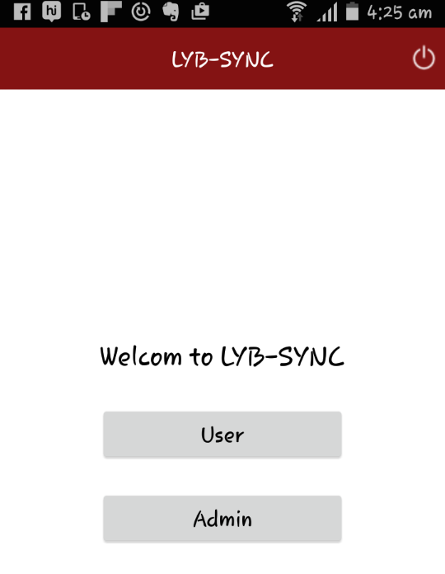

**Fig1. User and Admin module**

**Description:** User and Admin modules of lyb-sync that performs above-mentioned operations. The advantages and approach of Lyb-Sync app is:

It is a user-friendly interface, gives fast access to the database, less error, more storage capacity, quick search facility.

|  |  |  |  |  |  |
| --- | --- | --- | --- | --- | --- |
| **Test Case #** | **Module** | **Test Case** | **Steps to execute Test Case** | **Expected Test Result** | **Status** |
| 1 | Lyb Sync Modules  (**User**, **Admin**) | Verify that the launching page of lyb sync app has 2 modules: User and Admin | 1. Click on Lyb Sync app to make sure launching page is displayed. 2. User, admin are displayed on the middle of the page. | User, Admin modules should be displayed on the middle of the page. | **Pass** |

# **BODY**

Implementation of ‘Lyb-Sync’ application enables readers to navigate through book availability and titles in the library. Here book loaner timings are tracked and kept a record, so that other users are benefited and it even supports in sharing a book with who is search of same book for saving time. By this the student or the other book readers doesn’t have to walk in to the library to check the book availability, which indeed saves lot of time and effort. This is a sensitive feature that can be easily integrated to the existing system.

**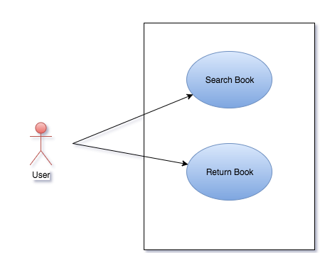**

**Use Case Diagram of User Module**

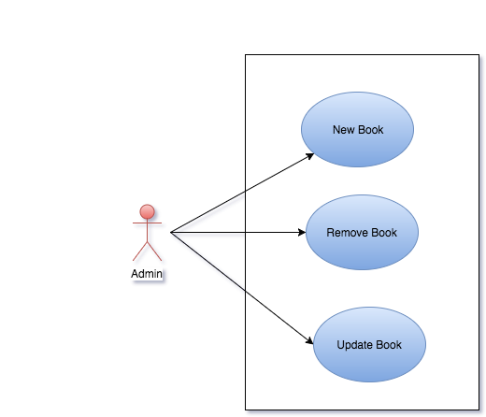

**Use Case Diagram for Admin Module**

The above mentioned are the main functionalities that are responsible by User and Admin. User will be able to search for book and its availability. And also user will be able to return the book after usage. The Admin will be able to add new books to the existing inventory, can remove the book and can also modify or update the book details.

As discussed in fig.1 there are two modules. After launching the lyb-sync app, user can see two buttons. One is user and the other is admin/client for Lyb-Sync.

**2. ADMIN LOGIN PAGE**

**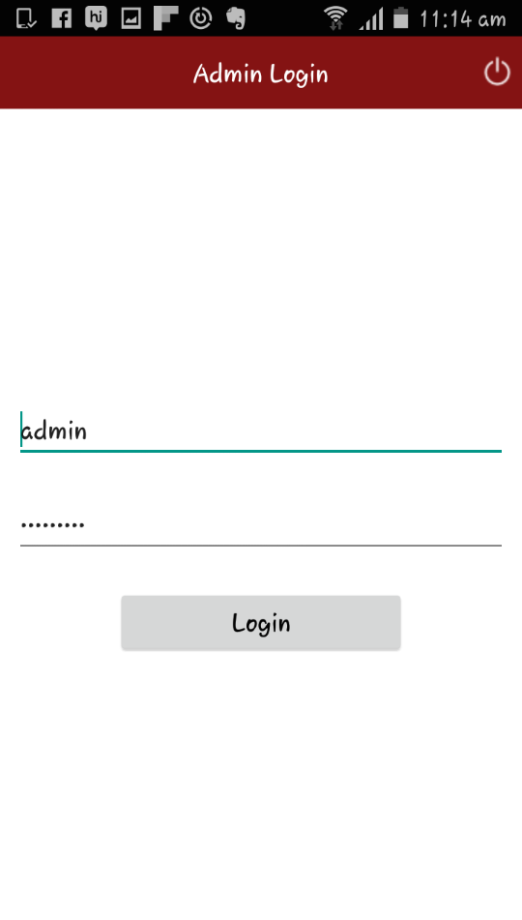**

**Fig2. Admin login page**

**Description:** The admin of Lyb-sync clicks on Admin as shown in Fig1, then he/she is lead to admin login page. Here admin has to give credentials in order to manage and make any kind changes to the application. Once client enters user id and password, he should click on login to operate the application. Any further transaction like removing or updating book records will be managed and modified by admin. It will basically track on how many books are available inside library.

In User module, the user after launching Lyb-Sync application should click on user as shown in fig.1 to perform the tasks that are discussed above.

|  |  |  |  |  |  |
| --- | --- | --- | --- | --- | --- |
| **Test Case #** | **Module** | **Test Case** | **Steps to execute Test Case** | **Expected Test Result** | **Status** |
| 2 | Admin Login Page (**Admin**) | To verify that the 2 input fields username, password and login button are displayed on the admin login page | 1. Enter valid username. 2. Enter valid password, which should match the criteria. 3. Click on login to make changes in the admin module. | Admin should be able to enter credentials in fields of username and password and login to the admin module. | **Pass** |

**3. USER LOGIN PAGE**

**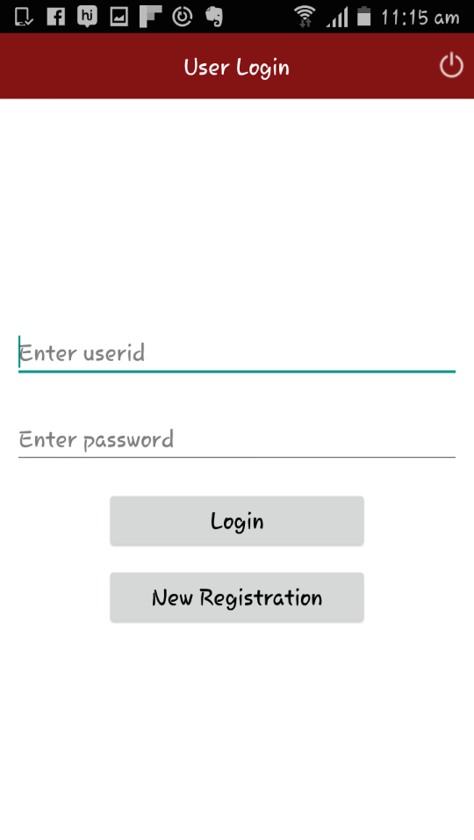**

**Fig3. User Login Page**

**Description:** Here the reader has to enter credentials if he/she is an existing user to search for books and to view book availability. Each user has unique ID in the database that allow performing activities in the application.

If the user is new to Lyb-sync, user should click on new registration. Below is the interface that is displayed when a user clicks on new registration tab.

|  |  |  |  |  |  |
| --- | --- | --- | --- | --- | --- |
| **Test Case #** | **Module** | **Test Case** | **Steps to execute Test Case** | **Expected Test Result** | **Status** |
| 3 | User login Page  (**User**) | 1. To verify that the two input fields username, password and login button are displayed on the user login page.  2. To verify that new registration button is displayed on the bottom center of the page. | 1. If new user, click on new registration 2. Enter valid username. 3. Enter valid password that should match the criteria to login. 4. Click on login to login to user module to perform further operations. | User should be able to click on new registration if at all its new user and then should be able to login to user module by entering username and password. | **Pass** |

1. **NEW USER REGISTRATION PAGE**

**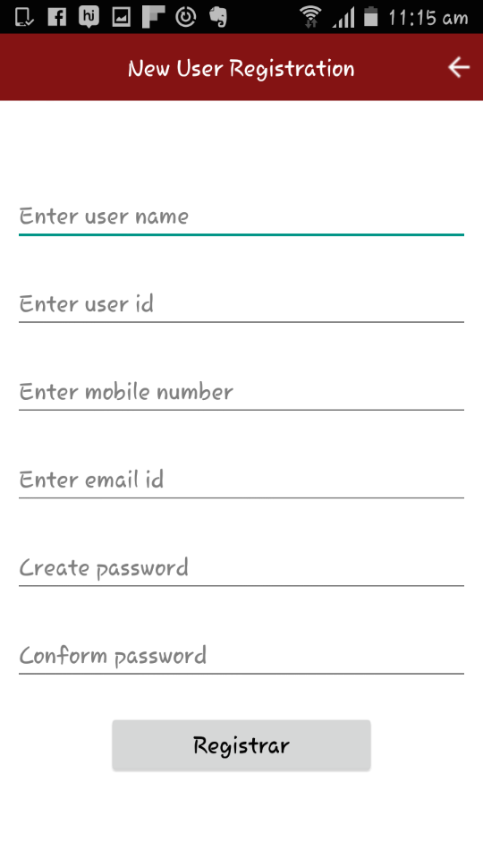**

**Fig4. New user registration Page**

**Description:** User should enter respective details in fields to become an authorized user for Lyb-sync. In the place of user name, user should give full name. User Id accepts numerical values. CWID should be entered if the user is student in California State University Fullerton. The field mobile number takes ten digit numbers and notifies if user misses any number. Email that is used on daily basis should be given, further for notifications. Lastly in password field, user should meet Strong criteria to meet the system security level. After entering all the above details, the user shall click on register and there ends new registration process.

If the user is authorized user, then he can directly give credentials to make use of Lyb-sync application. As discussed about fig.3 after giving valid credentials by clicking on login button, the user is taken to next page.

|  |  |  |  |  |  |
| --- | --- | --- | --- | --- | --- |
| **Test Case #** | **Module** | **Test Case** | **Steps to execute Test Case** | **Expected Test Result** | **Status** |
| 4 | New user registration (**User**) | 1. To verify that the new user registration page is displayed with username, user id, mobile number, email id, password. 2. And also register button is displayed on the bottom of the page. | 1.User should enter displayed fields such as username, user id, mobile number, email id, create password.  2. Click on register button. | User should be able to register to lyb sync by entering username, user id, email id, mobile #, password and then click on register. | **Pass** |

**5. AUTHORIZED USER PAGE**

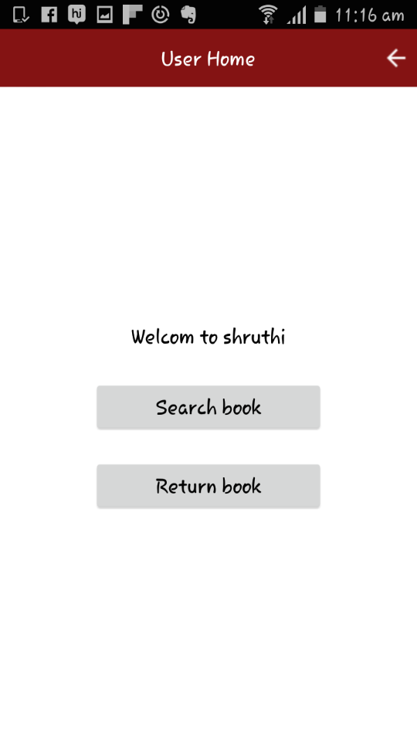

**Fig5. Authorized user Page**

**Description:** As the database has got information stored in it about the user, it displays user’s name. Here the user can perform two operations.

If the user wants to search for book availability then he needs to click on search book. After completion of reading the book while returning the book, the user should click on return book to make the book available for other users.

Fig6 is displayed when user clicks on Search book.

|  |  |  |  |  |  |
| --- | --- | --- | --- | --- | --- |
| **Test Case #** | **Module** | **Test Case** | **Steps to execute Test Case** | **Expected Test Result** | **Status** |
| 5 | Authorized User Page  (**User**) | 1. To verify that user home page has got search book button in the center of the page. 2. To verify that user home page has got return book button on the center of the page | 1. User should click on search to book to search for book availability. 2. User should click on return book to return the book to inventory. | User should be able to view and click on search and return book and they must be working. | **Pass** |

**6. SEARCH BOOK PAGE**

****

**Fig6. Search Book Page**

**Description:** In search bar, reader can type book title to check the availability and to know the status of the book. I have already added one book in database through admin module. In fig6, user after entering book title in the given search bar and click on search button, then the user will be taken to the next page if entered book is available.

|  |  |  |  |  |  |
| --- | --- | --- | --- | --- | --- |
| **Test Case #** | **Module** | **Test Case** | **Steps to execute Test Case** | **Expected Test Result** | **Status** |
| 6 | Search Book Page  (**User**) | 1. To verify that the user is able to view, search bar. 2. To verify that the blueprint is viewed stating “which title are you looking for?” 3. To verify that search icon is working when user enters book title. | 1.User should enter valid book title in the search bar and click on search. | User must be able to view search bar and should be able to enter book title and search for book by clicking on search icon. | **Pass** |

**6.1 BOOK - AVAILABILITY AND LOCATION PAGE**

**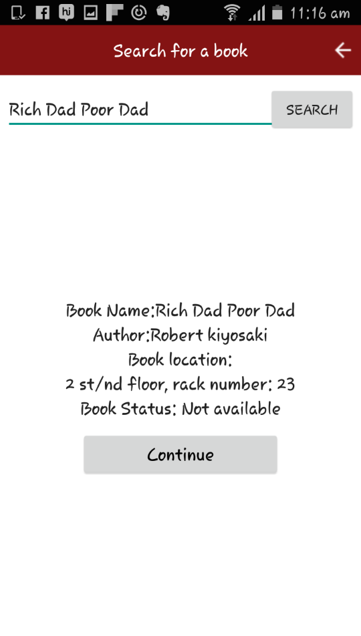**

**Fig6.1 Book Availability and Location Page**

**Description:** If the entered title is valid it displays book name, author, and book status and book location. Here it shows that the book is “Not available” as another user already takes it. So, if the user want to be on wait list then can click on continue and can see book availability time.

|  |  |  |  |  |  |
| --- | --- | --- | --- | --- | --- |
| **Test Case #** | **Module** | **Test Case** | **Steps to execute Test Case** | **Expected Test Result** | **Status** |
| 6.1 | Book Availability and location Page | 1. To verify that user is able to view entered book title, author, and book location. 2. To verify that user is able to view continue button to perform further operations | Users if interested, after looking the book status should click on continue to loan chosen book. | User must be able to click on continue once the page displays book title, author, book status and book location. | **Pass** |

**6.1.1 WAITING LIST QUERY**

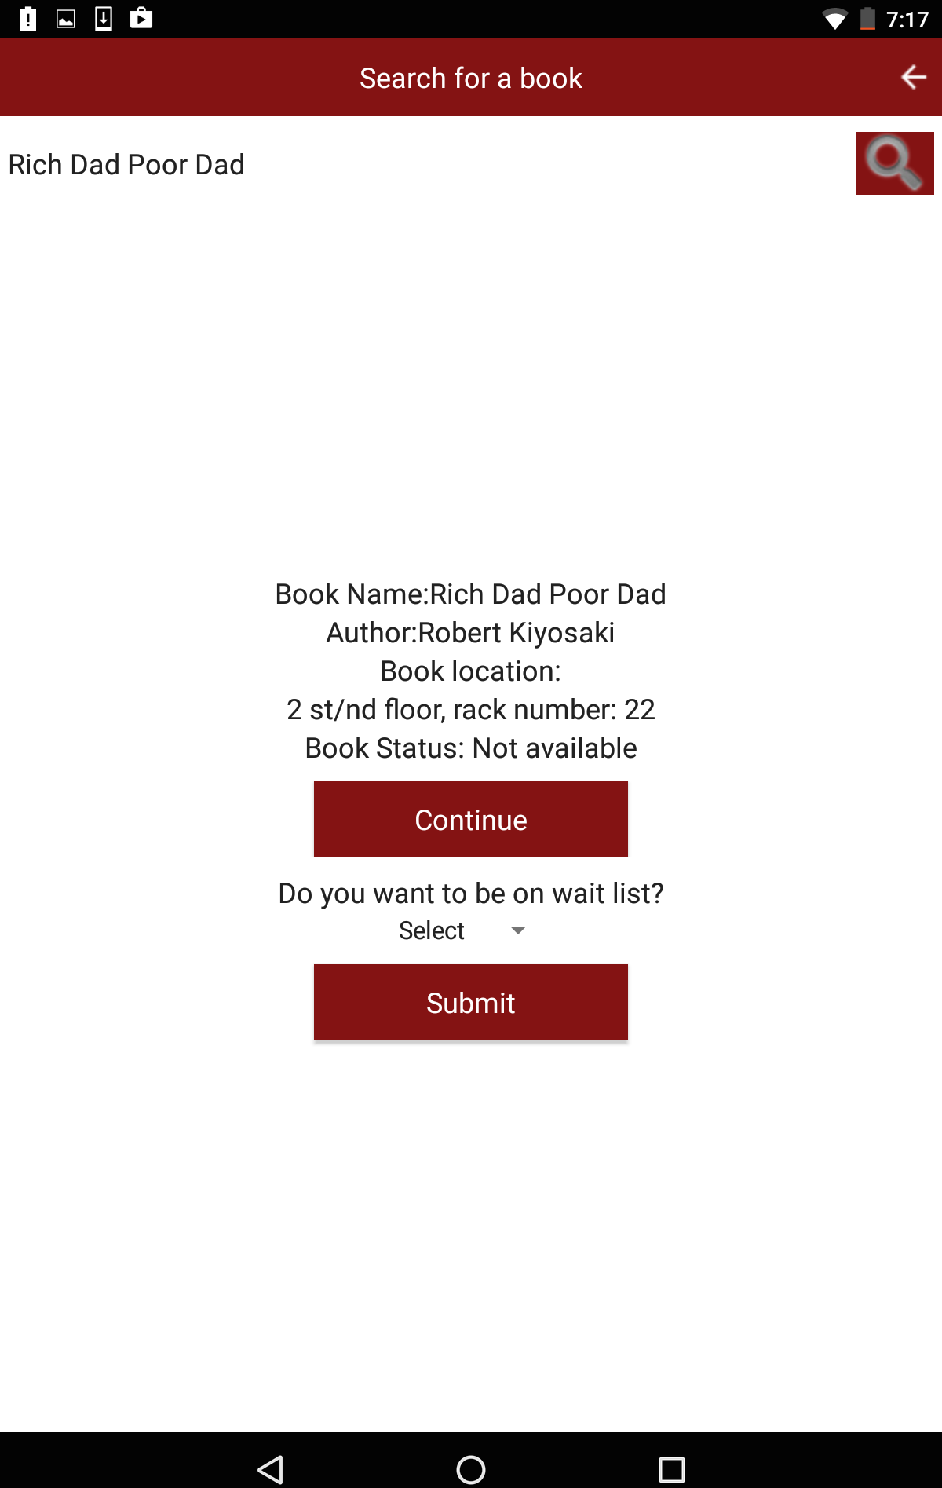

**Fig6.1.1 Waiting list Query**

|  |  |  |  |  |  |
| --- | --- | --- | --- | --- | --- |
| **Test Case #** | **Module** | **Test Case** | **Steps to execute Test Case** | **Expected Test Result** | **Status** |
| 6.1.1 | Waiting list query  (**User**) | 1. To verify that user is able to view book name, author, book location, and book status. 2. To verify that user is able to view a query “Do you want to be on wait list?” after clicking on continue. 3. To verify that the user is able to select from drop down from query and click on submit. | 1. User, if interested to be on the waiting list then should click on continue by selecting ‘Yes’ from drop down and submit. 2. Here if the user is not interested to be on the waiting list, then user should select ‘No’ from drop down and click on submit. | User should be able to view book name, author, book location and book status. Here the book is not available. So, user should be able to click on continue and answer the query if interested to be on the waiting list. | **Pass** |

**6.1.2 WAITING LIST # (Book Status: Not Available)**

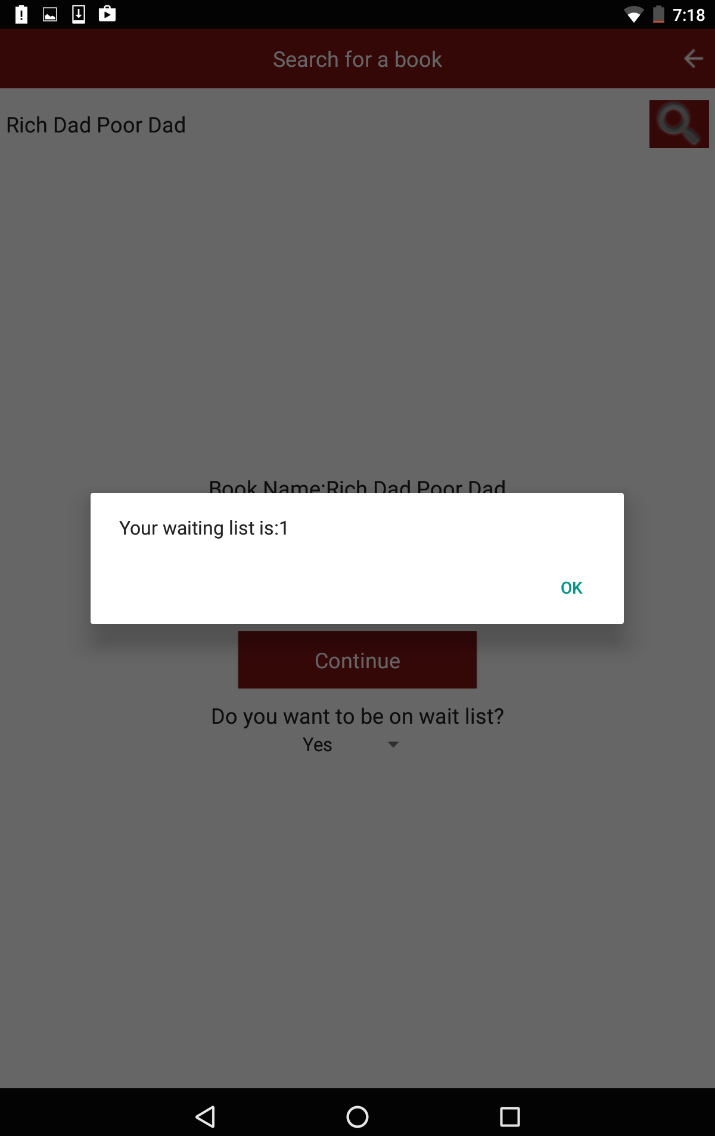

**Fig6.1.2 Waiting List # (Book Not Available)**

**Description:** Here it is displaying that the book is not available in fig 7.1.1. So if the user or the student want to access the same book then he should click on continue. By clicking on continue lyb-sync probes a query stating “ Do you want to be on the waiting list?” then if the user is willing to be on the waiting list then he should select ‘Yes’ from the drop down then the app displays a pop-up where he can see waiting list #. Finally by clicking on ‘Ok’ that particular user will be put in the highest priority and likewise if there are other users who are seeking for the same book will be doing the same. This way user can see his waiting list if at all the book is not available.

|  |  |  |  |  |  |
| --- | --- | --- | --- | --- | --- |
| **Test Case #** | **Module** | **Test Case** | **Steps to execute Test Case** | **Expected Test Result** | **Status** |
| 6.1.2 | Waiting list # when book is not available. (**User**) | 1. To verify that the user is able to select ‘Yes’ from query drop down and click on submit or not. 2. To verify that Lyb sync displays or gives a pop up of waiting list number. 3. To verify that after knowing the waiting list number user is able to click on ‘Ok’. | User, after answering the query as ‘Yes’ and by clicking on submit he/she is viewed the waiting list number with ‘Ok’ button. | User must be able to view and select ‘Yes’ or ‘No’ from the drop down of query and then click on submit if user choses ‘Yes’. Then the user must be able to view a pop-up referring to the waiting list #. If user is willing to be on it then should be able to click on ‘Ok’. | **Pass** |

**6.2 BOOK - AVAILABILITY AND LOCATION PAGE**

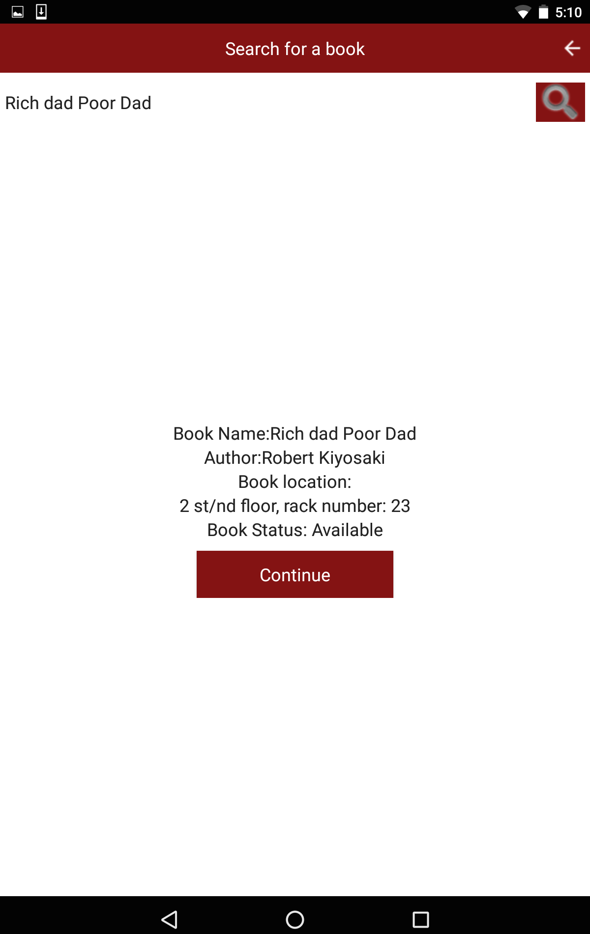

**Fig6.2 Book Availability and Location Page**

**Description:** If the entered book title is valid then Lyb-sync displays book name, author, book location, and book status. The book location, it displays in detail by displaying in which floor the book is available, rack number. The user will be able to view this because; the admin has entered precise book location while entering book details in the database. Here the status of the book is “Available”. Then the user can click on continue to take the chosen book. So by clicking on ‘continue’ it displays, below queries that are displayed in the next screenshot.

|  |  |  |  |  |  |
| --- | --- | --- | --- | --- | --- |
| **Test Case #** | **Module** | **Test Case** | **Steps to execute Test Case** | **Expected Test Result** | **Status** |
| 6.2 | Book Availability and Location Page | 1. To verify whether user is able to view book name, author, book location and book status after entering valid book title. 2. To verify that user is able to click on continue button if interested. | User should give valid book title then lyb sync displays book name, author, book location and book status and then the user should click on continue to loan the book. | User must be able to view book details such as entered book title, author, and book location and book status. And then lyb sync should allow the user to click on continue to reserve the book for certain time. | **Pass** |

**6.3 SELECTING # OF HOURS (Book Loan) and UPDATING SHARE OPTION**

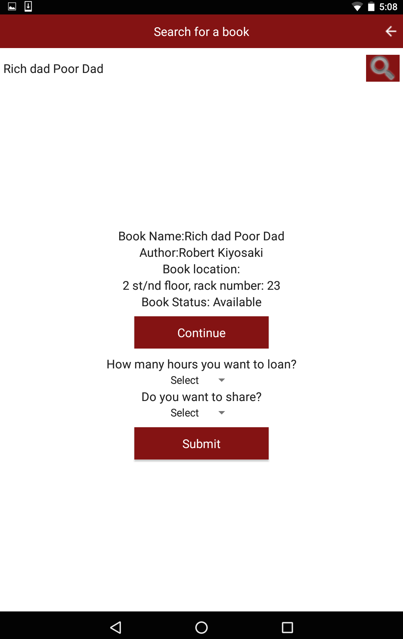

**Fig 6.3 Selecting # of hours (Book Loan) and updating share option**

**Description:** User after seeing the entered book status as ‘available’, after clicking on continue, Lyb-Sync displays two more queries. One that asks for how many hours does the user want to loan the book for. Here there is a drop down that allows the user to loan a book at max for 5 hours starting from one hour. And the other options indeed another feature in Lyb-sync i.e., ‘share’ option. This is to share book with another person if he gets any request for share. But for this the first user should update as Yes from the drop down, then the other person (second) who is looking for the same book will be able to ping the other person and request to share. But if the first user is not willing to share then he can update as ‘No’, by this he will not receive any request from other users to share the same book.

|  |  |  |  |  |  |
| --- | --- | --- | --- | --- | --- |
| **Test Case #** | **Module** | **Test Case** | **Steps to execute Test Case** | **Expected Test Result** | **Status** |
| 6.3 | Selecting # of hours and updating share option (**User**) | 1. To verify that the user is able to view book name, author, book location, book status and continue button. 2. To verify that user is able to view 2 queries such as **‘**How many hours you want to loan?’ and ‘Do you want to share?’ and submit button. 3. To verify each query has drop down working or not. | Here the book status is available. So, if the user is interested then should click on continue to loan the book by answering two queries and then click on submit to reserve the selected book. | User shall be able to view book title, author, book status and book location along with continue and submit button. The functionality behind submit should work by choosing ‘Yes or No’ from drop down from queries. | **Pass** |

1. **RETURN BOOK PAGE**

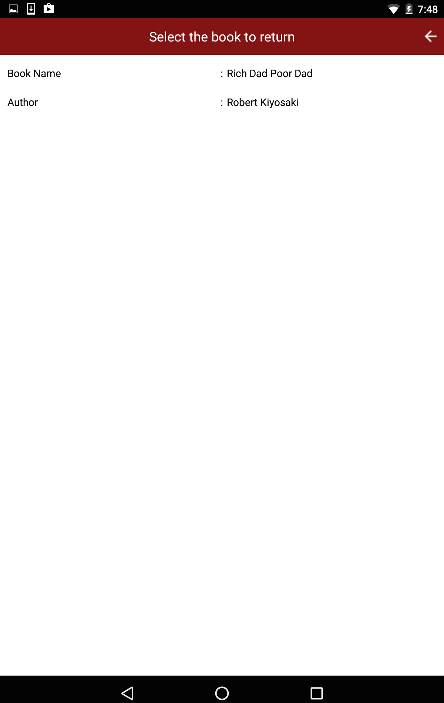

**Fig 7. Return Book Page**

**Description:** If the user wants to return book after opted time then he should give authenticated credentials to login and then click on return book like as shown in fig 5. When the user clicks on return book option then the interface displays books that are taken by the user. Then user can click on the book that he has to return. This way the user will be able to select book if he wants to return particular book.

|  |  |  |  |  |  |
| --- | --- | --- | --- | --- | --- |
| **Test Case #** | **Module** | **Test Case** | **Steps to execute Test Case** | **Expected Test Result** | **Status** |
| 7 | Return Book Page  (**User**) | 1. To verify that the user is able to land on returning page after clicking on return book. 2. To verify that the user is able to view his/her chosen books in their lyb sync account. | User should click on return book in order to return a book. Then list of books that are taken by the user are displayed. | User must be able to view list of books that are lent by clicking on return book. | **Pass** |

**7.1 CONFIRMATION QUERY (Return Book)**

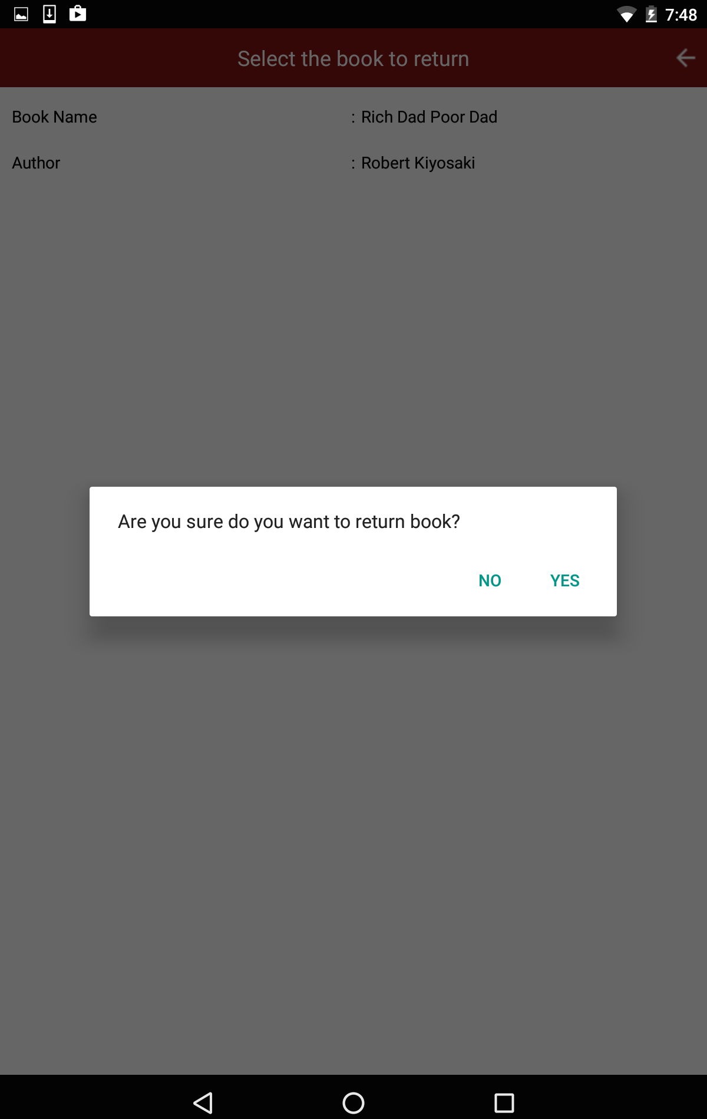

**Fig7.1 Confirmation Query (Return book)**

**Description:** After the process that is explained in fig 7, in order to seek confirmation from the user while returning the book, lyb-sync gives a pop-up stating “Are you sure do you want to return book?”

Then if the user wants to return the selected book then he should click on ‘Yes’. This way lyb-sync seeks confirmation from the user/student/reader while returning a book to the inventory and making that book available to the next user.

|  |  |  |  |  |  |
| --- | --- | --- | --- | --- | --- |
| **Test Case #** | **Module** | **Test Case** | **Steps to execute Test Case** | **Expected Test Result** | **Status** |
| 7.1 | Confirmation Query- Return Book  (**User**) | 1. To verify that the user is able to view list of lent books by clicking on return book or not. 2. And also to check whether lyb sync gives a pop-up to the user after selecting a particular book such as ‘Are you sure do you want to return the book?’ 3. To verify that query has got ‘Yes’ or ‘No’ options and they are functional or not. | User should initially login to reach this page. And then to return book user should click on return book and then the above page is displayed and user should give long press on displayed book to return and answer the query by giving confirmation to lyb sync. | User shall be able to view lent books after clicking on return books. So that the user can choose and return the book by selecting ‘Yes’ from the pop-up.  And if the user clicks on ‘No’ then the selected book will be remaining back in the user’s account. | **Pass** |

* 1. **DISPAYS # OF RECORDS AFTER RETURNING BOOK**

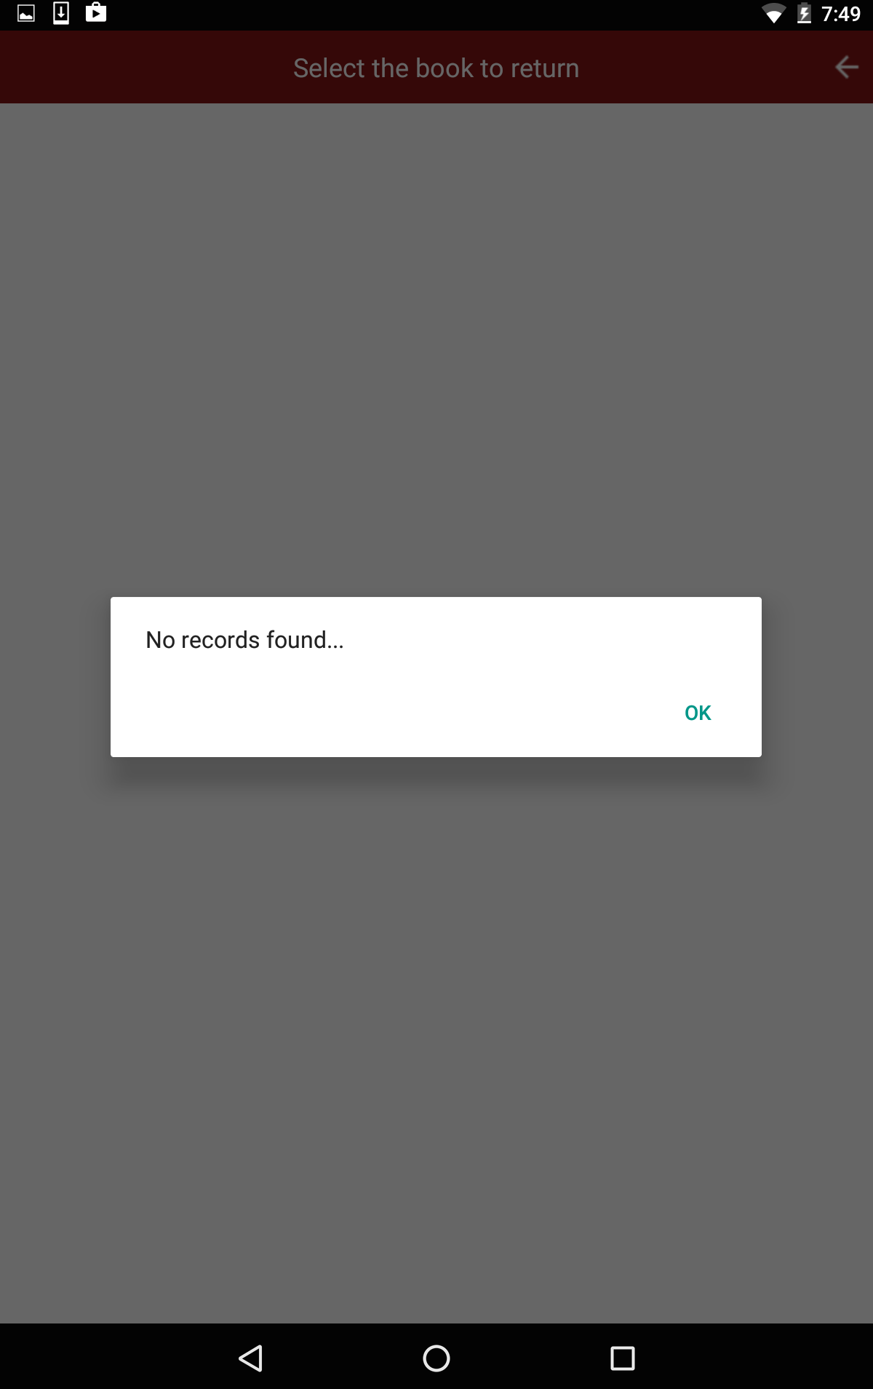

**Fig 7.2 Displays # of records after returning book**

**Description:** Here if the user choses single book and clicks on ‘Yes’ while lyb-sync seeks confirmation from the reader. This page displays other than the returned books. Simply it displays the books, which are taken by the user. Here, this particular user has taken only one book. So, we don’t get to see other books in his account. Finally after clicking on ‘Yes’ it displays a pop-up stating, “No records found” then user by clicking on Ok he can go back to the previous screen.

|  |  |  |  |  |  |
| --- | --- | --- | --- | --- | --- |
| **Test Case #** | **Module** | **Test Case** | **Steps to execute Test Case** | **Expected Test Result** | **Status** |
| 7.2 | Displays # of records after returning book  (**User**) | 1. To verify that the user is able to return the books that is selected by clicking on return books. 2. To verify that after selecting ‘Yes’ from the pop-up lyb sync displays number of records that are available. 3. Here, the user has only one book that is returned. So this test case is to verify whether it gives a pop-up as ‘No records found’. | User after clicking on return books, multiple books are displayed which is lent. Then the user has to click on the particular book that is to be returned. Lyb sync gives a pop-up confirmation then the user has to click on ‘Yes’ to return book. | User must be able to return the books that are selected by user after clicking on return books. And user should be able to see a pop up stating ‘No records found’ after selecting ‘Yes’ from pop-up. | **Pass** |

Back to Admin module, below is the screenshot of admin home.

1. **ADMIN HOME PAGE**

**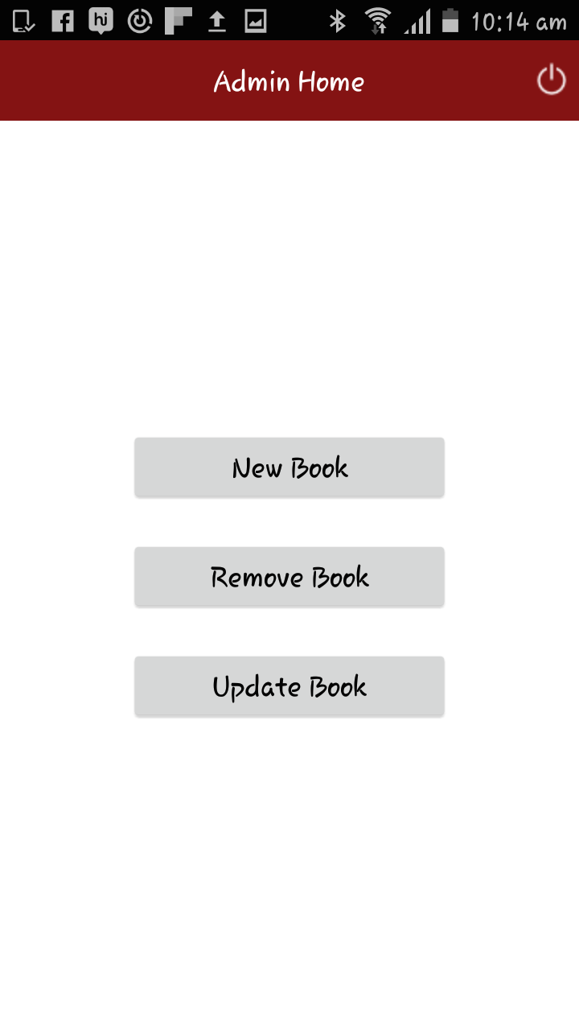**

**Fig8. Admin Home page**

**Description:** Here admin can perform all the operations that are discussed above in introduction. In order to add new book, admin has to click on new book to enter a new book record into the database. I have already added “Rich dad and Poor dad”. As the book is already registered by the admin into the database in fig7, the user was able to see the status of the book and location.

If Admin, clicks on new book below are the fields that are to be entered to store that particular book in book inventory.

|  |  |  |  |  |  |
| --- | --- | --- | --- | --- | --- |
| **Test Case #** | **Module** | **Test Case** | **Steps to execute Test Case** | **Expected Test Result** | **Status** |
| 8 | Admin Home page  (**Admin**) | 1. To verify that the admin is able to view admin home page after logging in to the admin module. 2. To verify that the admin is able to view new book, remove book, update book functionalities in the bottom center of the page. | Admin should login to the admin module by giving correct credentials and then he/she will be able to view three functionalities such as new book, remove book and update book in admin home page. | While admin logs into the admin module he must be viewed three functionalities in the bottom center of the page such as new book, remove book and update book. | **Pass** |

**8.1 NEW BOOK ENTRY RECORD PAGE**

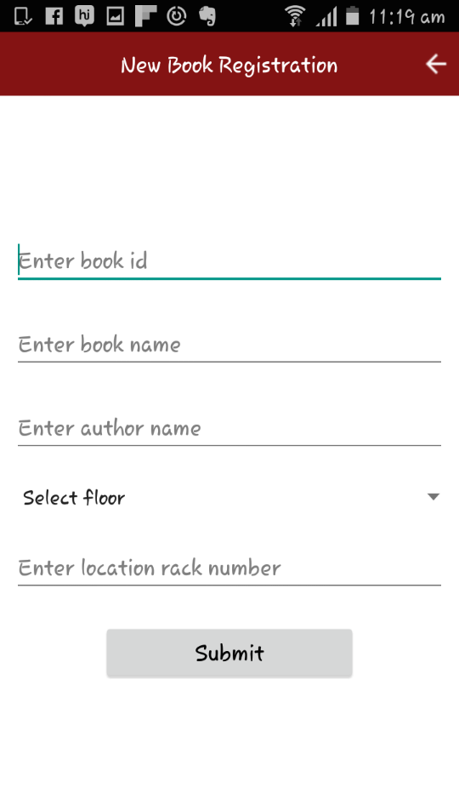

**Fig8.1 New Book Entry Record Page**

**Description:** To add new book in Lyb-Sync, admin access should be available. If the admin is authorized then this page can be displayed on screen. In book ID field, unique ID shall be entered. So that it shouldn’t mess up with other books. Book name should be entered as appears on book. In author name, if there are multiple authors then the admin should add the entire authors name by separating their names with comma.

|  |  |  |  |  |  |
| --- | --- | --- | --- | --- | --- |
| **Test Case #** | **Module** | **Test Case** | **Steps to execute Test Case** | **Expected Test Result** | **Status** |
| 8.1 | New book entry record page (**Admin**) | 1. To verify that admin is able to view new book registration page. 2. To verify that admin is able to view fields like enter book id, enter book name, enter author, select floor, and enter location rack number. 3. To verify that after filling the details submit button is working or not. | Admin should login to lyb sync to enter new book details and then fill the respective fields to add a new entry to the existing inventory. | The admin should be able to login and view the details such as enter book id, enter book name, enter author, select floor, enter location rack number in the admin new registration page. And after filling the details admin should be able to click on submit to enter a new book to the storage. | **Pass** |

**8.2 BOOK LOCATION ENTRY PAGE**

**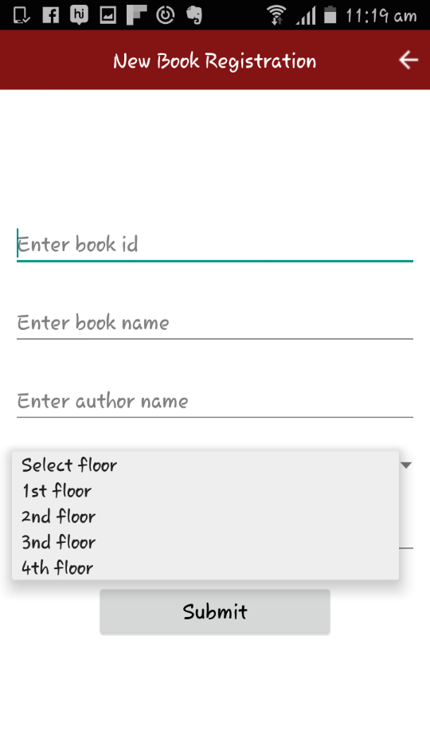**

**Fig8.2 Book Location Entry Page**

**Description:** To update the book location of new book entry, admin while clicking on Select floor, there will be a drop down listing various floors. According to the space available in the library, book location should be saved along with rack number and click on submit to register the new book. This process completes the registration of new book.

|  |  |  |  |  |  |
| --- | --- | --- | --- | --- | --- |
| **Test Case #** | **Module** | **Test Case** | **Steps to execute Test Case** | **Expected Test Result** | **Status** |
| 8.2 | Book Location Entry Page  (**Admin**) | 1. To verify that the admin, while selecting the floor, lyb sync is displaying drop down or not. 2. To verify that whether in the drop down it has got four floor mentioned or not. 3. To verify that the admin is able to choose the floor on which the book has to be placed. | The admin in order to choose or select the floor in which the book has to be placed on. He should select floor from drop down and add book to that particular floor. | The admin should be able to view enter book id, enter book name, enter author, drop down for selecting floor and submit button. Here the admin should be able to click on particular floor. | **Pass** |

1. **REMOVE BOOK PAGE**

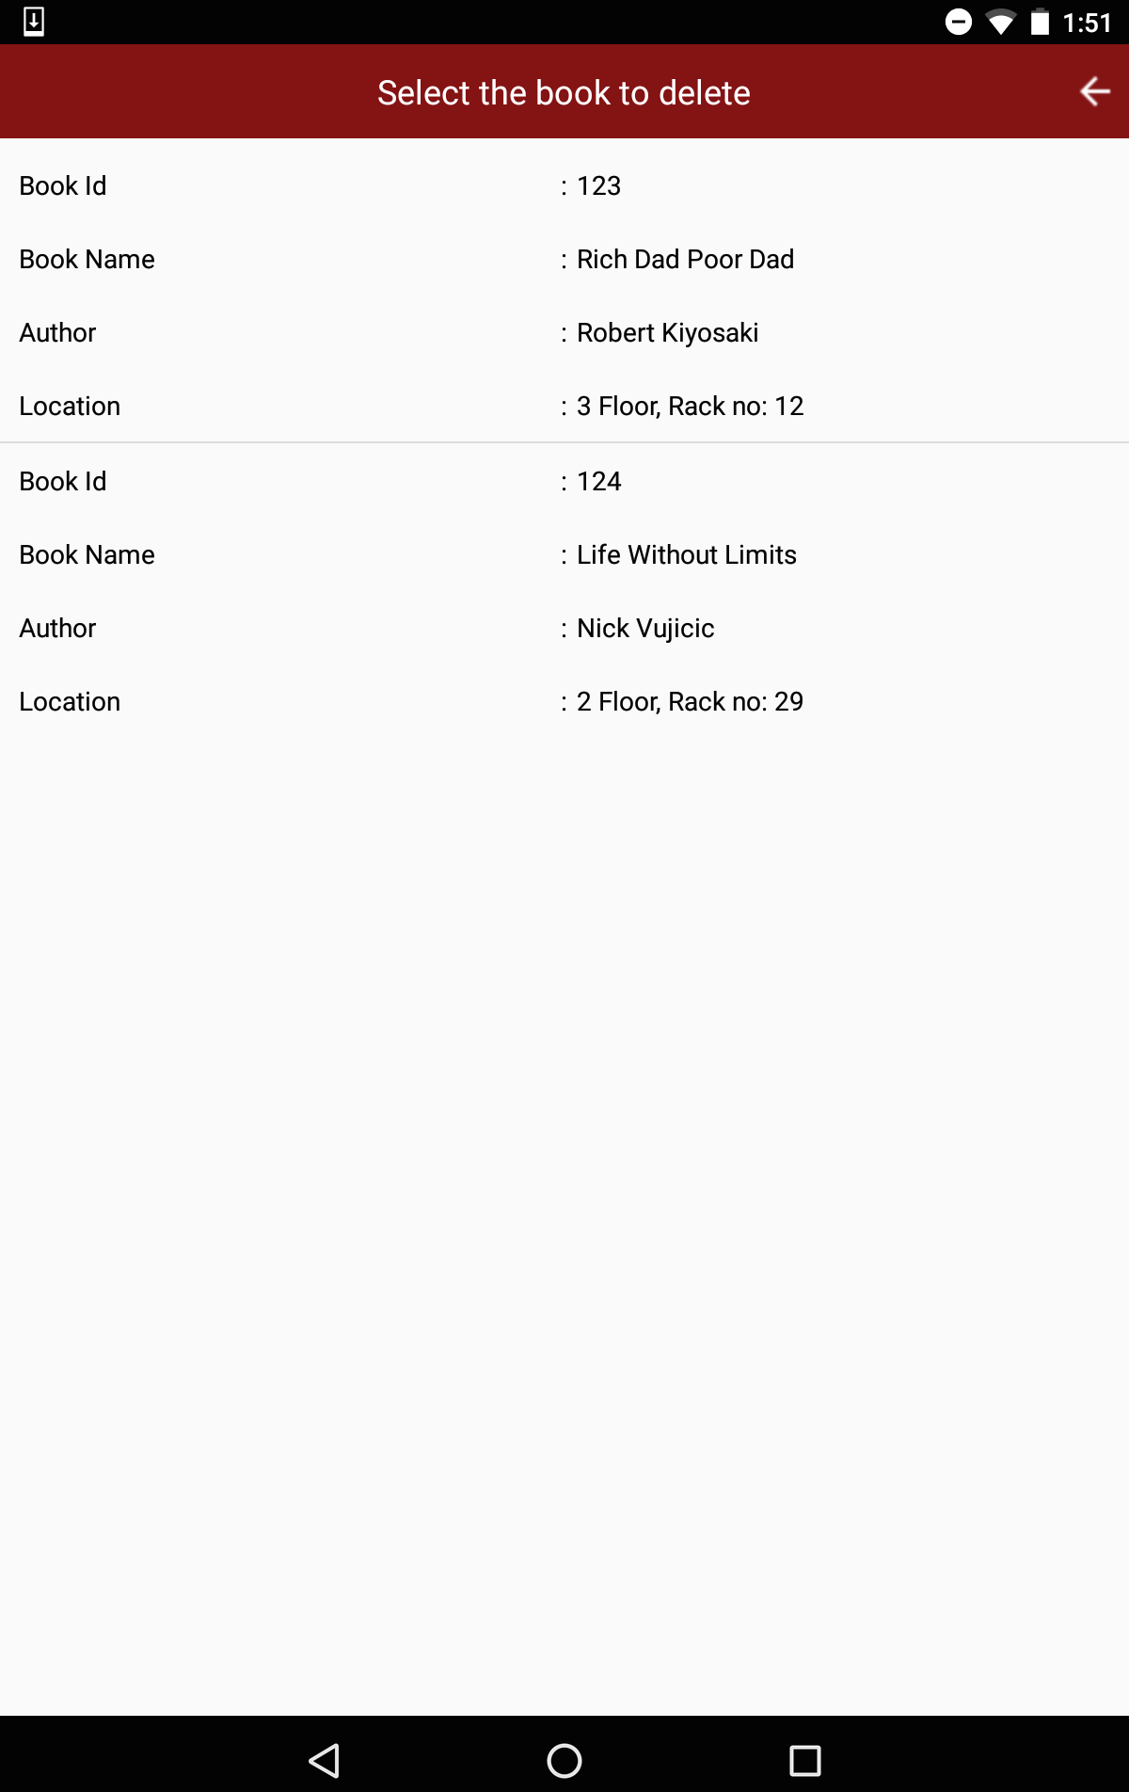

**Fig9. Remove Book Page**

**Description:** In order to remove books from the storage one should have admin access. If it’s authorized person, the interface leads to admin home page then to remove or delete any book from the existing record, he should click on remove book. Then it displays the list of books that are stored in database. And then it asks to select the book that has to be deleted. This process completes the selection of book that has to be removed from the records.

|  |  |  |  |  |  |
| --- | --- | --- | --- | --- | --- |
| **Test Case #** | **Module** | **Test Case** | **Steps to execute Test Case** | **Expected Test Result** | **Status** |
| 9 | Remove Book Page  (**Admin**) | 1. To verify that the admin is able to view number and list of books those are in inventory while clicking on remove book. 2. To verify that the admin is able to select a book that should be deleted from the existing inventory. | Admin should be able to login to the admin module, to make changes to the inventory. If the admin is authorized the above page is displayed with number and list of books that are available till date. To remove book from the storage then admin should select a book to remove it from storage. | Admin should be able to view list of books that are available till date in the inventory. And also admin should be able to select a particular book that is to be deleted. | **Pass** |

**9.1 POP-UP FOR CONFIRMATION (Remove Book)**

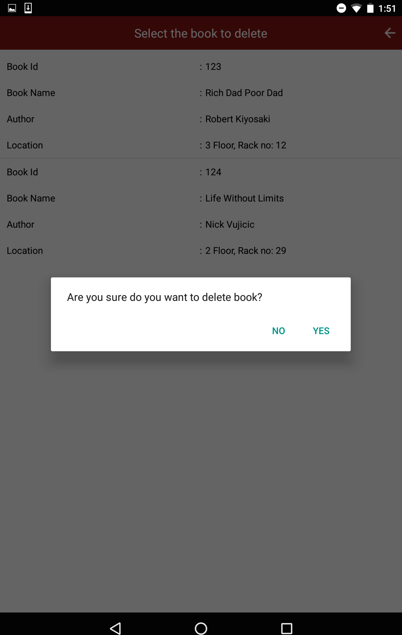

**Fig9.1 Pop-Up for Confirmation (Remove book)**

**Description:** After the above process that is explained beneath fig.10, Lyb-Sync asks for confirmation whether to delete the selected book from the existing record or not. If the admin clicks on ‘No’, the book still remains the inventory and if the admin clicks on ‘Yes’ then that selected book is removed from the records. This way Lyb-sync seeks confirmation from admin by giving a pop-up in order to delete a selected book.

|  |  |  |  |  |  |
| --- | --- | --- | --- | --- | --- |
| **Test Case #** | **Module** | **Test Case** | **Steps to execute Test Case** | **Expected Test Result** | **Status** |
| 9.1 | Pop-Up for confirmation- Remove Book  (**Admin**) | 1. To verify that the admin is able to view a confirmation pop-up stating “Are you sure do you want to delete the book?” 2. To verify that the admin is able to click on ‘Yes’ or ‘No’ for confirmation in order to remove the book from inventory. | Admin to remove the book from inventory, he/she should select a particular book or multiple books that are to be deleted from the database should click on ‘Yes’ after lyb sync displays confirmation query. | Admin should be able to view pop up confirmation once he/she selects book that are to be deleted from the storage.Lyb-sync should be able to click on ‘Yes’ or ‘No’ to delete the book. | **Pass** |

**10. UPDATE BOOK DETAILS PAGE**

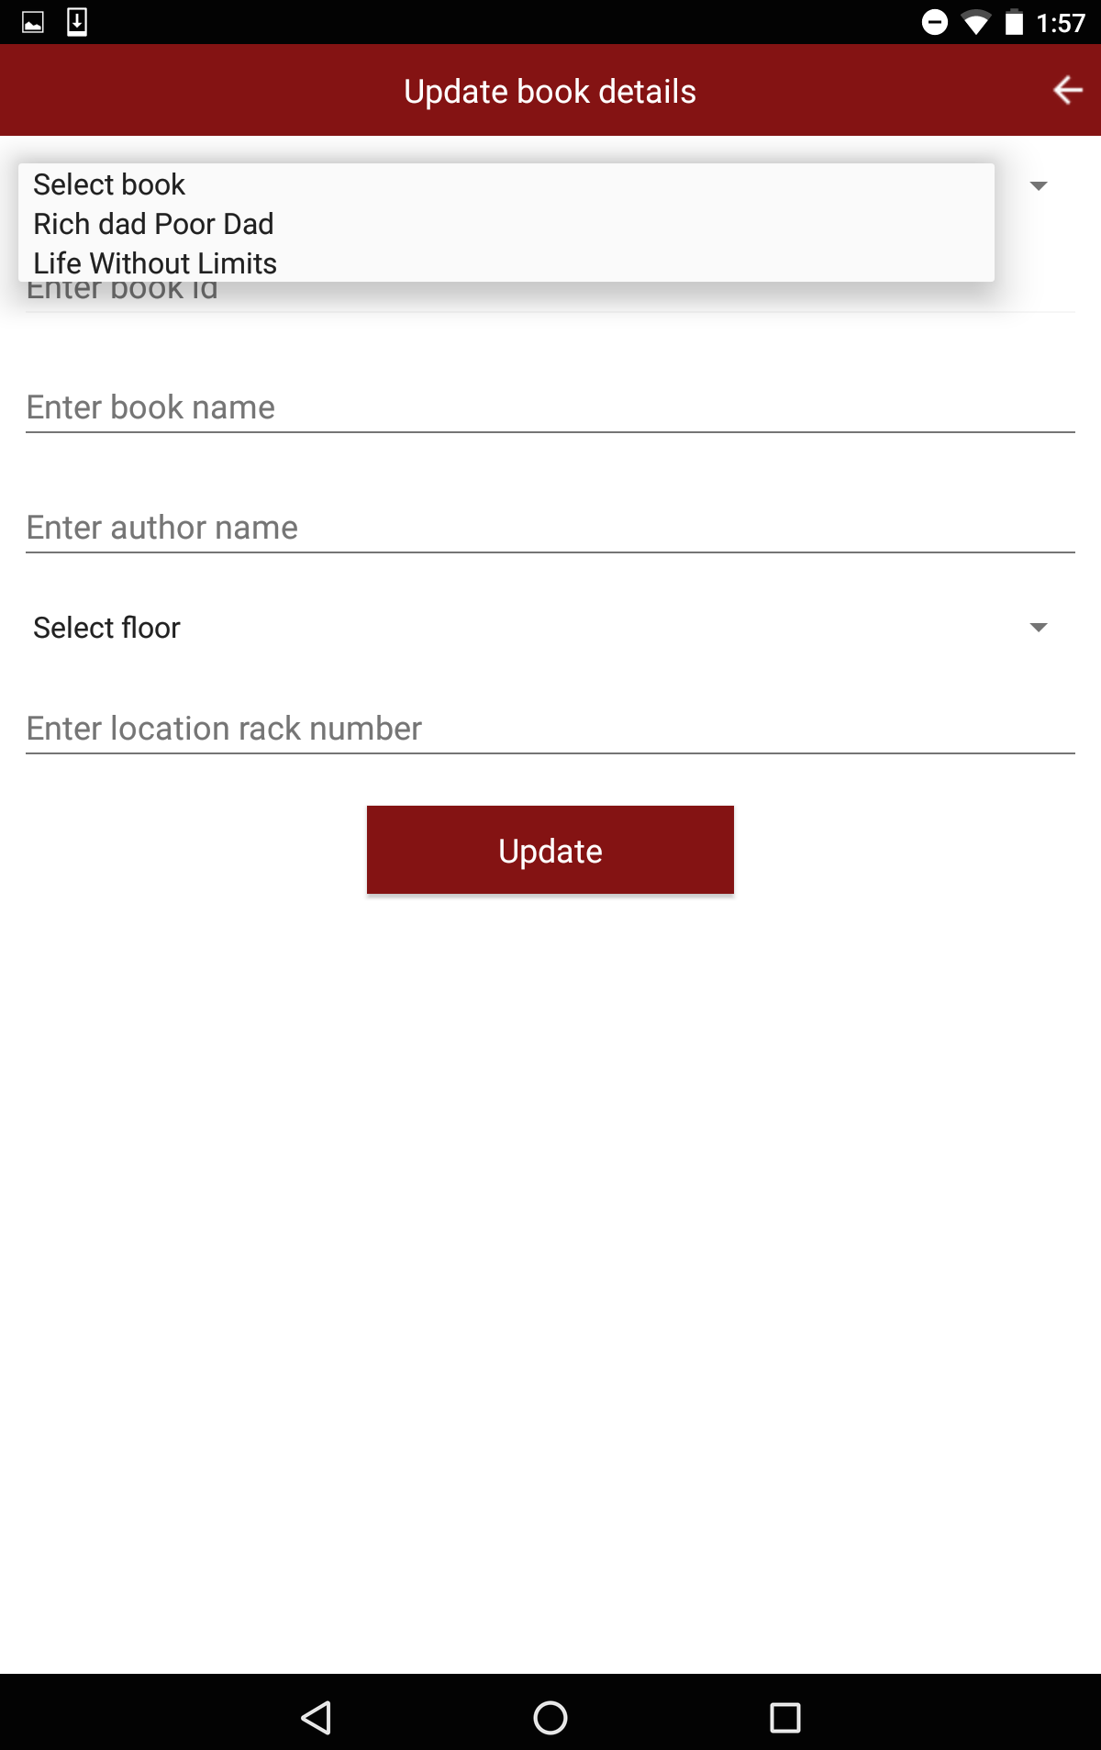

**Fig 10. Update Book Details Page**

**Description:** To update book existing book details, one should have admin access. If he is authorized admin then he can view the above page. Here the admin can select book from the drop down and can also select the floor if in case that particular book has to be shifted to another floor. This way admin can update book details by selecting book and floor by giving changed location number.

|  |  |  |  |  |  |
| --- | --- | --- | --- | --- | --- |
| **Test Case #** | **Module** | **Test Case** | **Steps to execute Test Case** | **Expected Test Result** | **Status** |
| 10 | Update Book Details Page  (**Admin**) | 1. To verify that the admin is able to view select book, enter book id, enter book name, enter author name, select floor, enter location rack number fields in update book details page. 2. To verify that the two drop downs are functional and displaying the books that are entered in the database and all the four floors. 3. To verify that the update button is functional or not in update book details page. | A valid admin can make changes or update book details in update book details page. To change or modify or to update any details about a particular book, admin should select that particular book from the drop down and can change the floor number by selecting another floor number from drop down of select floor. He/she can also update the rack number if the book is to be shifted to another rack. | The admin should be able to view select book with a drop down of existing books in the database and also book id, book title, author, select floor and enter location rack number.  The drop down must be functional. After filling the fields to update an existing book record update button should be functional. | **Pass** |

**PROJECT SCHEDULE**

|  |  |  |  |  |  |  |  |
| --- | --- | --- | --- | --- | --- | --- | --- |
| **PHASE** | **TASK** | | | | | **DATE** | **STATUS** |
| **Setup** | Installed Android SDK, Android Development Tools, and Android platforms | | | Created Android Virtual Devices and connect hardware devices that are used for testing | | January | Complete |
| **Development** | Created Android project with source code, resource files and Android manifest file | | | | | February and March | Complete |
| **Debugging**  **And**  **Testing** | Build and run application in debug mode | Debug Application using Android debugging and logging tools | | | Tested Application using Android testing and instrumental framework | March, April | Complete |
| **User stories** | Structured and prioritized stories | | | | | January | Complete |
| **UML Diagrams** | Pictorial representation of modules basic functionalities | | | | | January | Complete |
| **Test cases** | Test cases for user and admin module | | | | | January, February | Complete |
| **Milestone 1** | Developed User module | | | | | March 17 | Complete |
| **Milestone 2** | Developed Admin module | | | | | April 14 | Complete |
| **Milestone 3** | Worked on suggestions for final draft | | | | | May 12 | Complete |
| **Publishing** | Configure, build and tested application in release mode | | Release LYB-SYNC | | | May 17, 2016 | Complete |

**Software Requirements**

|  |  |
| --- | --- |
| Programming language | Java (Android SDK) |
| Database | SQLite |
| GUI | Eclipse (Juno) |

**System Requirements (Windows)**

* Microsoft® Windows® 8/7/Vista (32- or 64-bit)
* 2 GB RAM minimum, 4 GB RAM recommended
* 400 MB hard disk space
* At least 1 GB for Android SDK, Emulator system images, and caches
* 1280 x 800 minimum screen resolution
* Java Development Kit (JDK) 7
* Optional for accelerated emulator: Intel® processor with support for Intel® VT-x, Intel® EM64T (Intel® 64), and Execute Disable (XD) Bit functionality.

**CONCLUSION**

Implementation of ‘Lyb-Sync’ application enables readers to navigate through book availability and titles in the library. In current library management system, we are lacking in letting the readers know book availability timings if there are less copies.

This is a very sensitive problem, which we often face inside the library when we have limited edition of specific books, and also when that specific book is on demand.

The application is developed for smartphones that are running on android operating system. Hence it would be useful and beneficial to multiple readers. And also all age groups can use the application.

This project enhances the existing automated management system. Lyb-Sync eliminates the confusion of wait time, lets the other users to schedule their day accordingly. This application has two modules in this project. One is user and the other is client/admin in Lyb-Sync.

This app helps students to navigate through availability of books and titles in the library and if not suggest the time of availability. This not only keeps track of the books loaner timings but also provides a platform to share the book loaner time with others; this helps to build brighter community with loads of knowledge sharing.

And also two strangers can also share their knowledge if at all the first reader updates the share option as ‘Yes’. According to me I feel that rather than studying alone knowledge improvises when there is a discussion among group members or two persons. Because every person, approaches a problem in a new way and that can be helpful in knowing things better.

There won’t be a situation for a student to repeatedly keep coming to the library just to know the availability; this saves lot of time and effort. This can be easily integrated into the already existing ecosystem and add more efficiency to the existing system.

With the app availability on mobile platform and easy accessibility it is more agile and terrific.  Thus the project brings a new idea for readers to access the book inside the library more frequently.

Thus the project “**LYB-SYNC”** can be altered in accordance with the additional requirements. Features such as implementing live chat when reader choses to share a book and also to get alerts just before time out period, probably 10-15 before. So that the readers will be given a heads up to return the book before leaving the library. This way reader doesn’t forget to return the book.

I have improved my technical skills in java by this project. The tutorials are helping me a lot in achieving milestones of this project. I feel that I’m managing and performing multi tasking by learning various languages together by implementing simultaneously.

All I can say is, I have achieved my first milestone for assignment 7 and for draft 2 I have learnt the process of importing source code into GitHub and for this final draft I did add test cases that were planned ahead or in the very initial stage of my project. The test cases helped me in achieving each and every single feature of my project. And for milestone 3, I structured my document and added project schedule, software, hardware requirements and made my application ready to watch in youtube.

This is the final document of my application ‘Lyb-Sync.’

# 

# **REFERENCES**

Tutorials of Author David Gassner in Lynda for

1. Java Essential training
2. Android studio essential training

Tutorials of Joe Marini in Lynda for

1. XML Essential training

Tutorials of James Williamson in Lynda for

1. HTML Essential training

Tutorials of Paul Tranl in Lynda for

1. HTML fundamentals

Tutorials of in Joseph Lowery in Lynda for

# Building Android and iOS Apps with Dreamweaver CC and PhoneGap

Tutorials of Bill Wienman in Lynda for

1. SQLite Essential training

As it’s my own idea I’m referring few IEEE papers, using Google and taking one of my friend’s help.

1. <http://ieeexplore.ieee.org.lib-proxy.fullerton.edu/stamp/stamp.jsp?tp=&arnumber=7216816>
2. <http://code.tutsplus.com/tutorials/learn-java-for-android-development-introduction-to-java--mobile-2604>
3. <https://teamtreehouse.com/tracks/android-development>
4. <http://ieeexplore.ieee.org.lib-proxy.fullerton.edu/stamp/stamp.jsp?tp=&arnumber=6614320>
5. <http://ieeexplore.ieee.org.lib-proxy.fullerton.edu/stamp/stamp.jsp?tp=&arnumber=6746846>
6. <http://ieeexplore.ieee.org.lib-proxy.fullerton.edu/stamp/stamp.jsp?tp=&arnumber=7332476>
7. <http://ieeexplore.ieee.org.lib-proxy.fullerton.edu/stamp/stamp.jsp?tp=&arnumber=7216816>

**SOURCE CODE:**

# <https://github.com/shruthi2903/597project_LybSync>

**YOUTUBE LINK:**

[https://youtu.be/ssrIgxSGiS8](https://youtu.be/ssrIgxSGiS8" \t "_blank)